MKY ipbb Gateway
Instruction

VR1968

http://ipbb.mky.com

Enter Your ID & Password:
Use Default Page http://192.168.1.1 or http://X.X.X.X:8080
Default Account is Username “root”, Password “root”
Then Click ”LOGIN” otherwise “CANCEL”

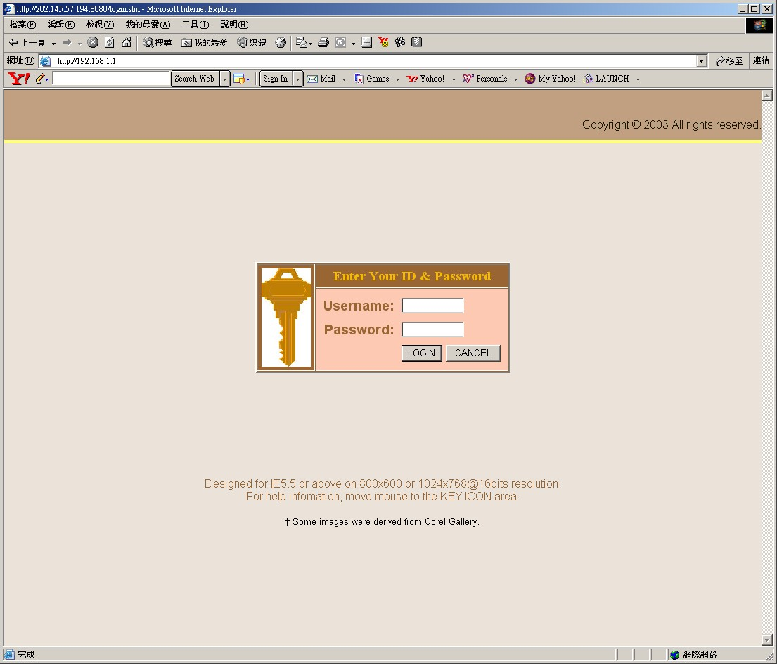

Time Zone:
Set up Local Area Time: (Depend on your Time Zone area to mark Daylight Saving)

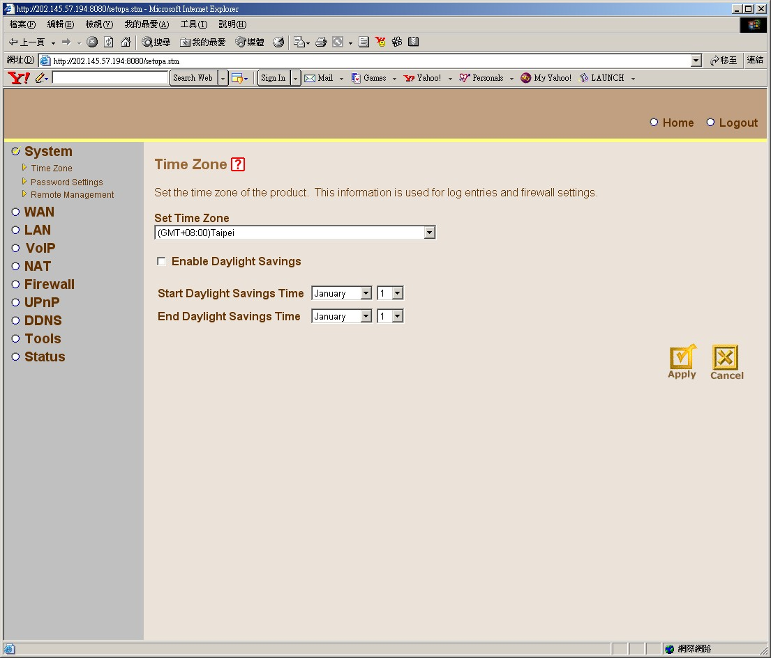

Password:
Change Default Password as New Password.

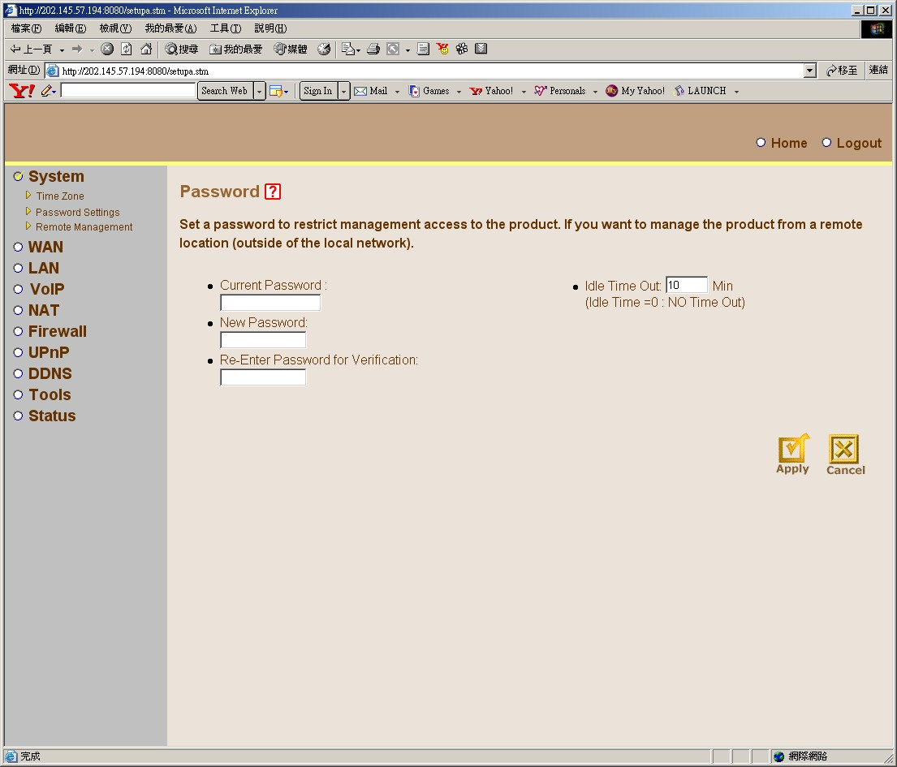

Remote Management:
Give a fixed IP address (WAN or LAN) as remote side or use Default 0.0.0.0 as Universal IP and default port is 8080.
Mark” Enable” to active the function.

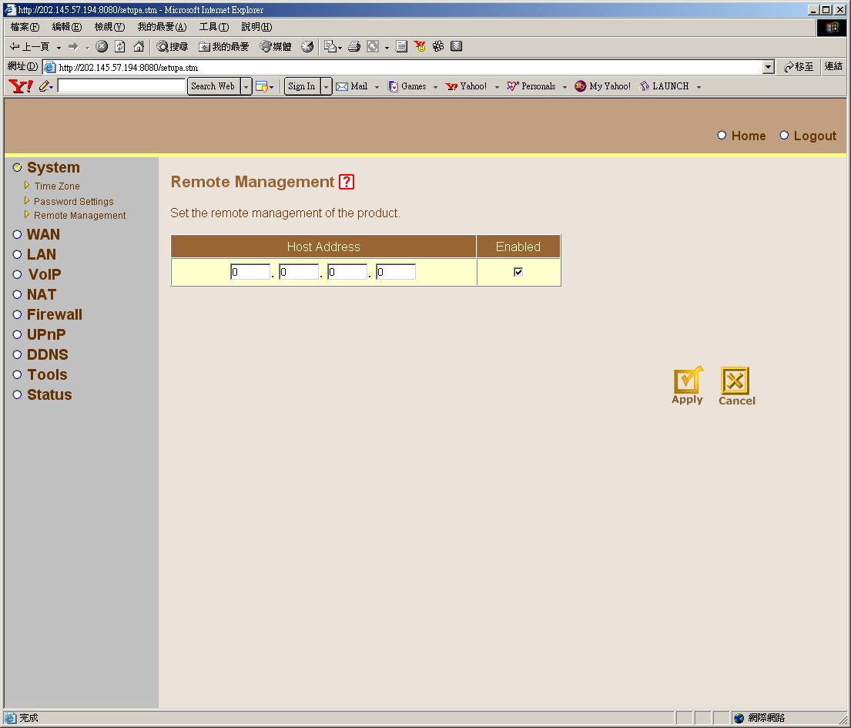

Network Settings:
Click User’s Network Service and Click “More Congratulation” to give more data like WAN IP, Username and Password.

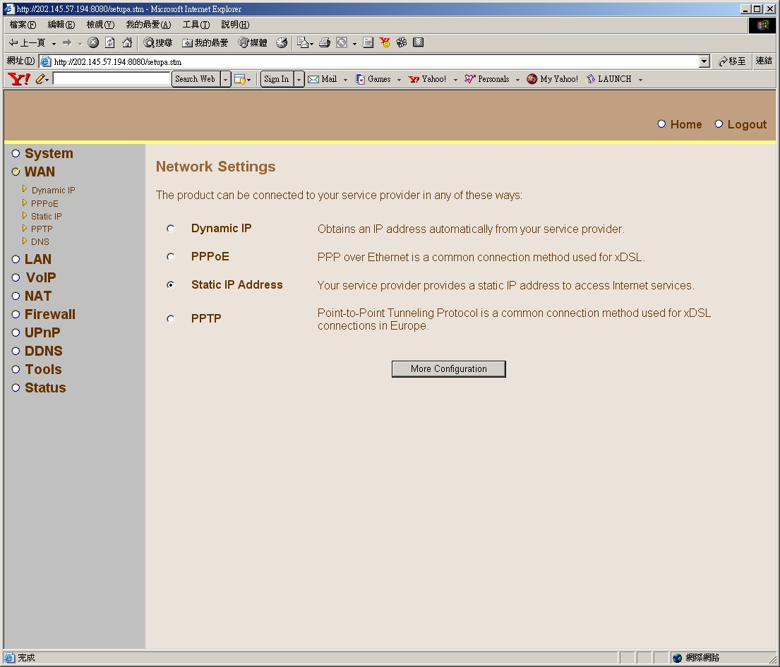

LAN Settings:
Configure Local Area Network IP and DHCP server active or not.

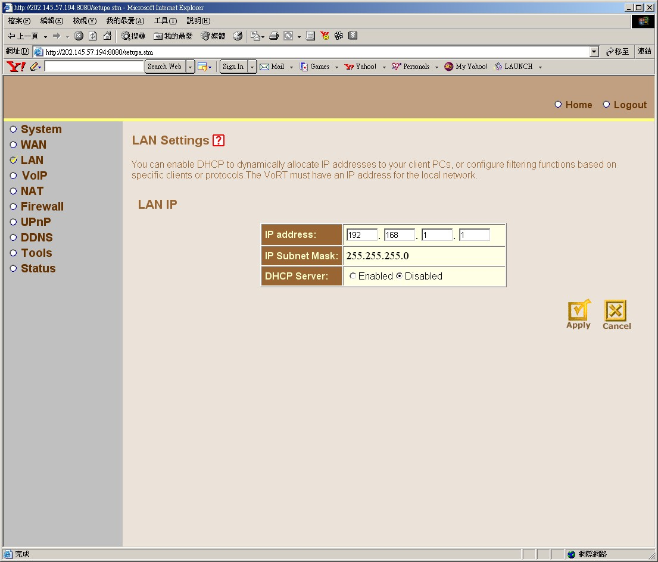

Dial Setting:
According to your local dial phone habit to change it.

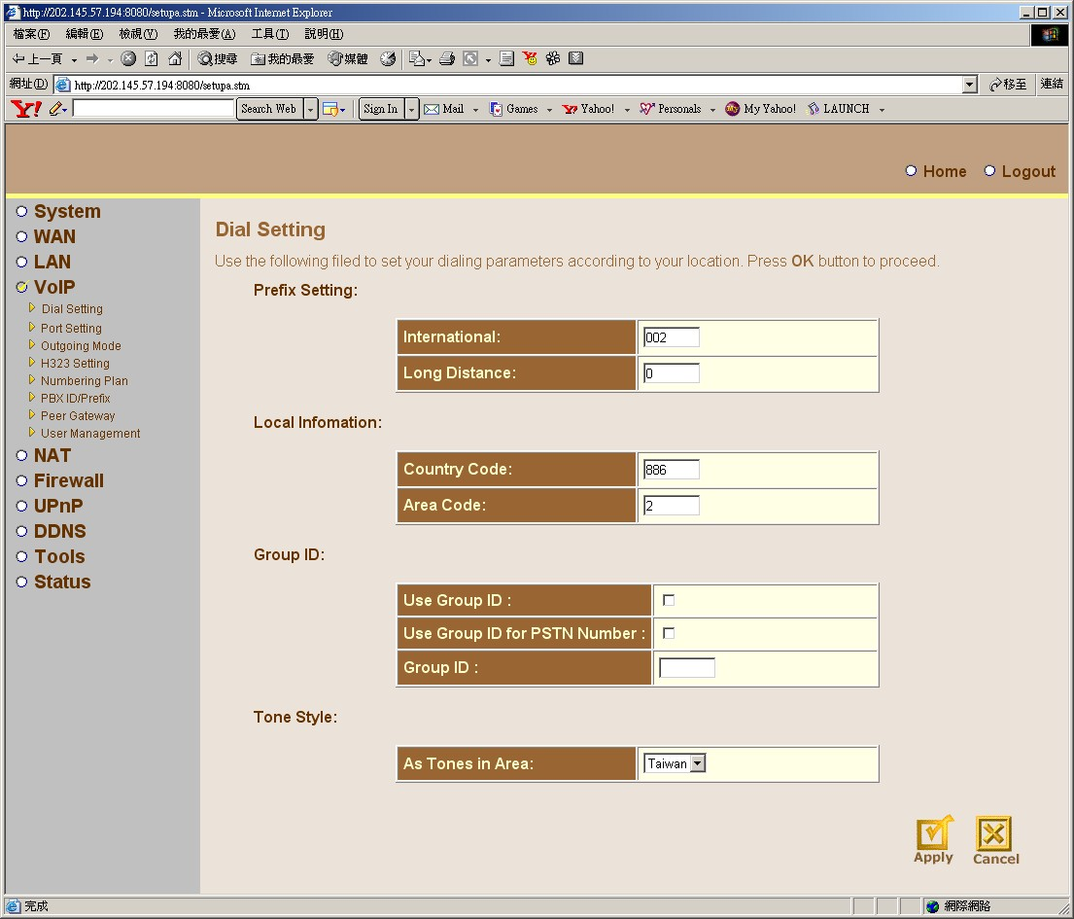
For example:
 | Area: |  | Taipei | Shang-Hai | New Orleans
Prefix Setting: | International: |  | 002 | 00 | 011
 | Long Distance: |  | 0 | 1 | 1
Local Information: | Country Code: |  | 886 | 86 | 1
 | Area Code: |  | 2 | 21 | 504
Tone Style: | As Tones in Area: |  | Taiwan | China | USA

Port setting:
Port Selected: Phone 1
Port General Setting:
Port Status: Enable
Port Type: Phone Set
Extension Number: ipbb Mmbership ID
For example: (87809999)
FAX Support: Auto FAX Detection
Security Setting:
Allow to Mark: All mark.
VOIP Authentication: no mark
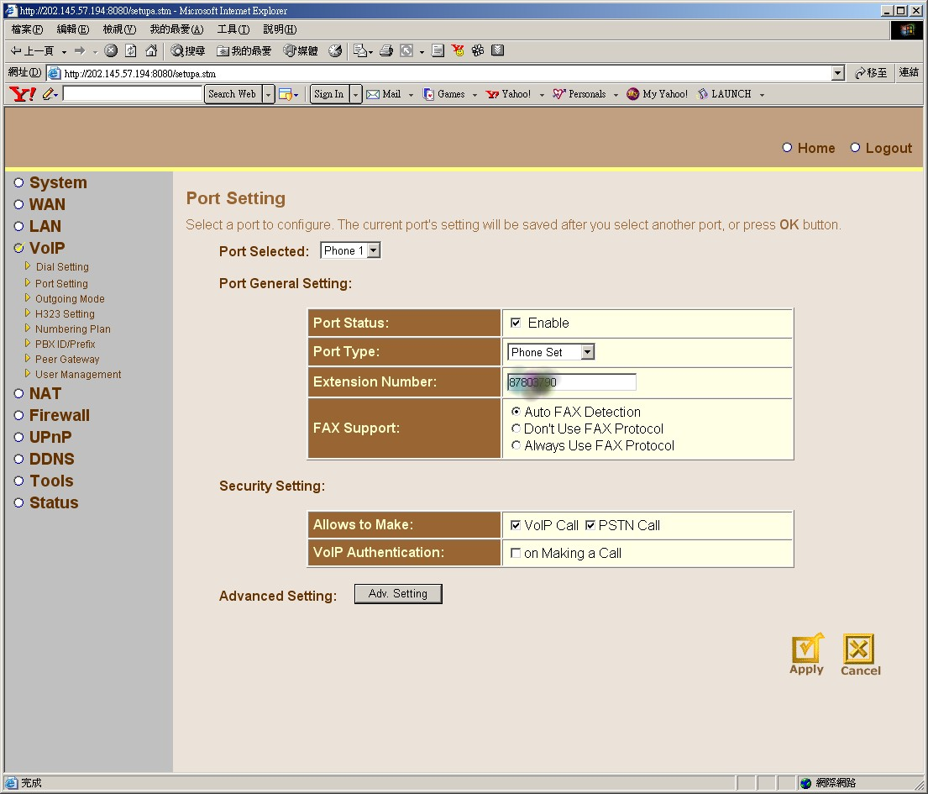
Click Adv. Setting.

Port Advanced Setting:
Phone/FAX Advanced Function: (Adjust Audio Volume)( -9 ~ 9 )
Input Volume Gain: -4
Output Volume Gain: 0

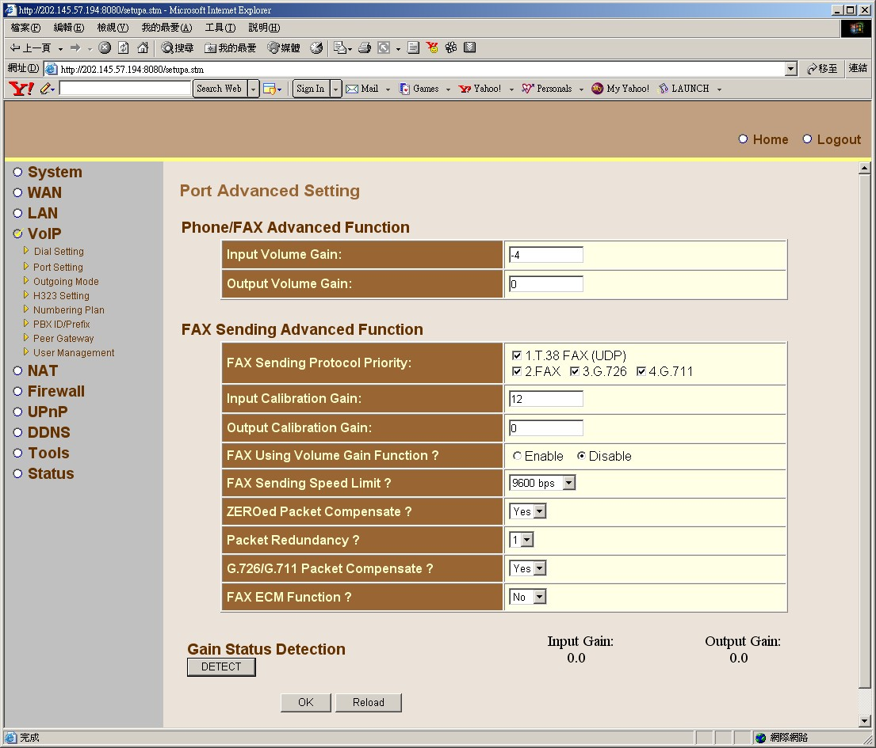

Outgoing Mode selection:
Mark “Operation with GateKeeper (ITSP Mode)”
And Click “NEXT”

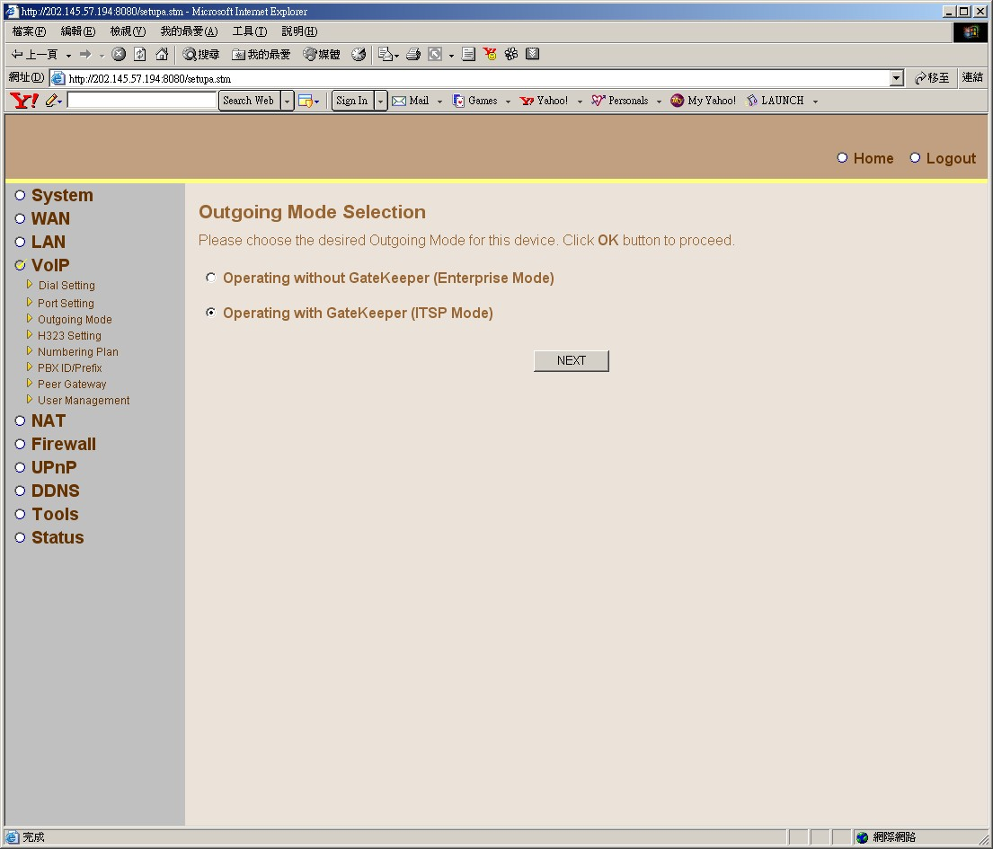

ITSP Mode (with GateKeeper):
GateKeeper Mode: Assigned IP
GateKeeper Setting:
IP Address: mkygk1.mky.com

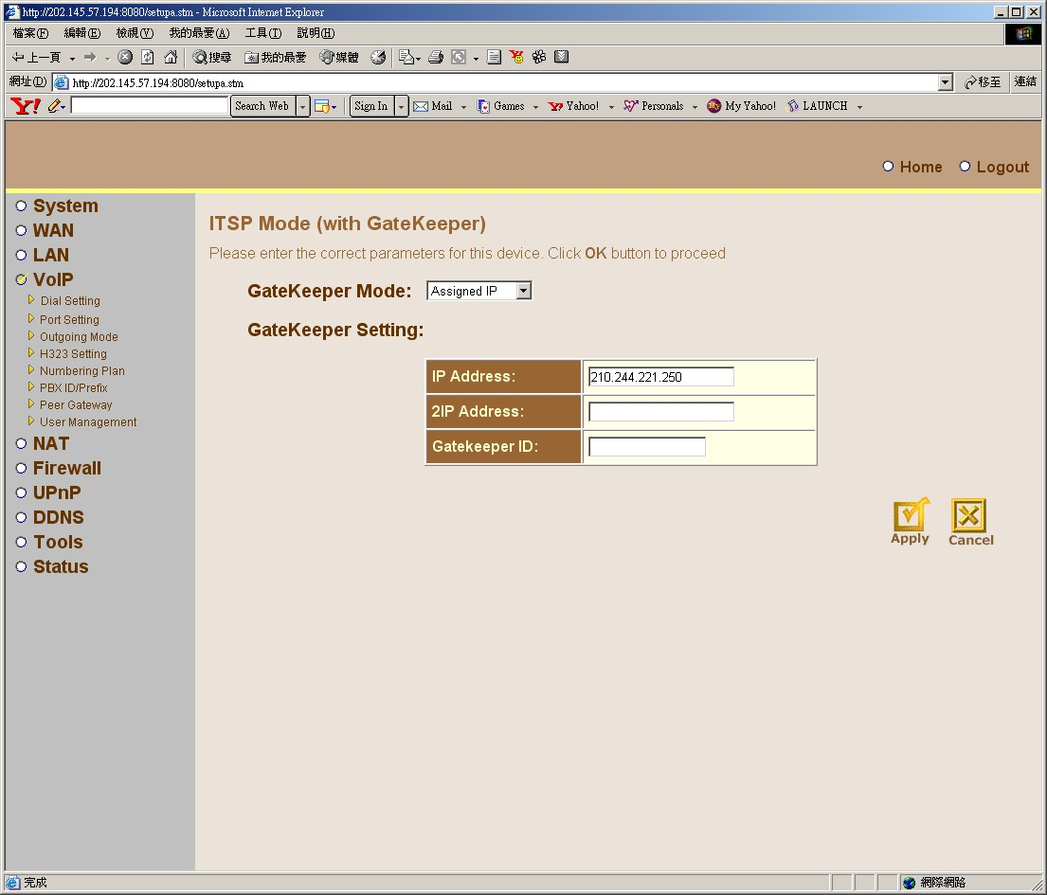

H.323 Setting:
H.323:
H.245 Mode: Tunneling
Time to Live: 100 sec.
Endpoint type: Gateway
Q.931 port: 1720
Other Options: mark Fast Connect, mark Allow Inband Ringback.
Alias:
H.323 ID:
User Input: ipbb Membership ID + * ipbb Password *
For example: (87809999*12345*)
Caller ID:
Use Caller ID: ipbb Membership ID
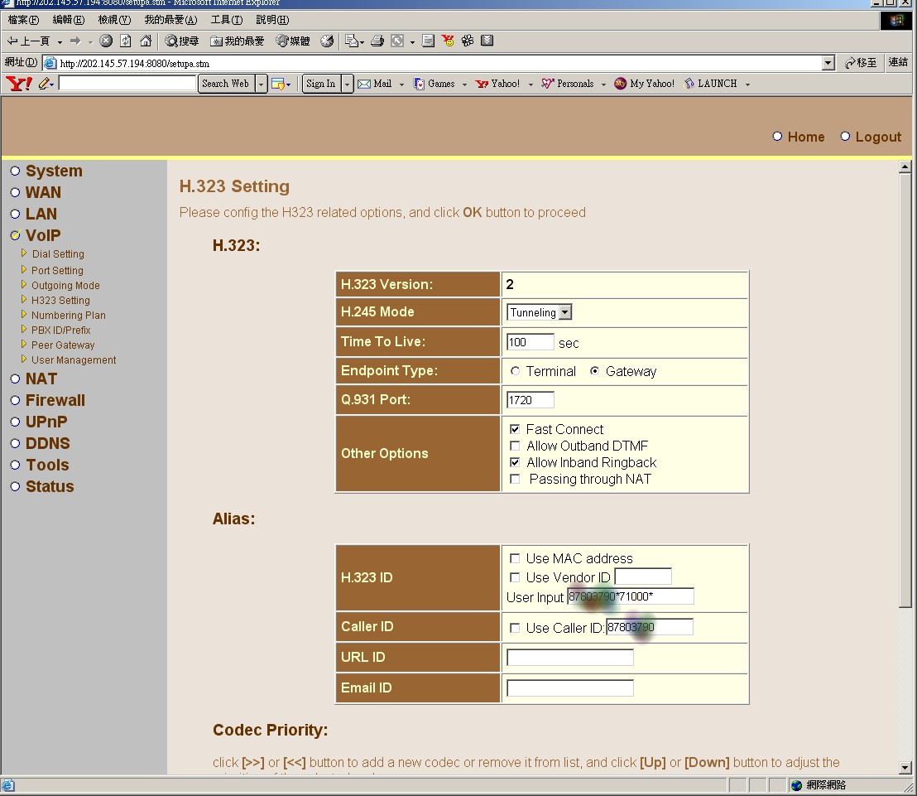

Codec Priority:
All left items move to Right column and put G.729a and G.729 in first.

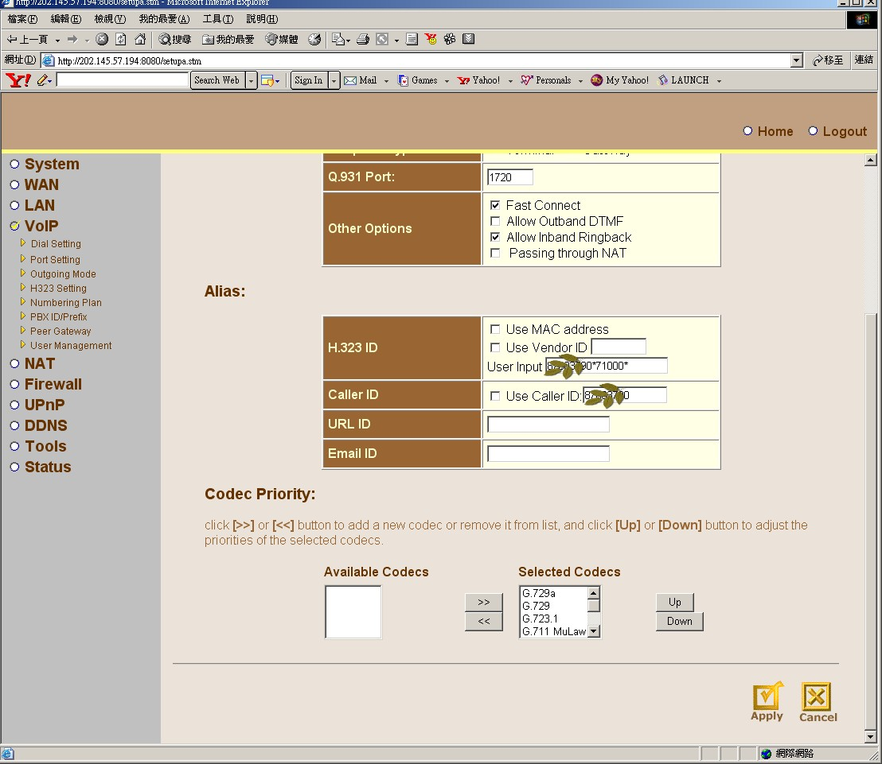

Numbering Plan:
Category: Outgoing.
AliasAddress Choice: only mark Dial Digitals
Number Policy: mark Use E.164

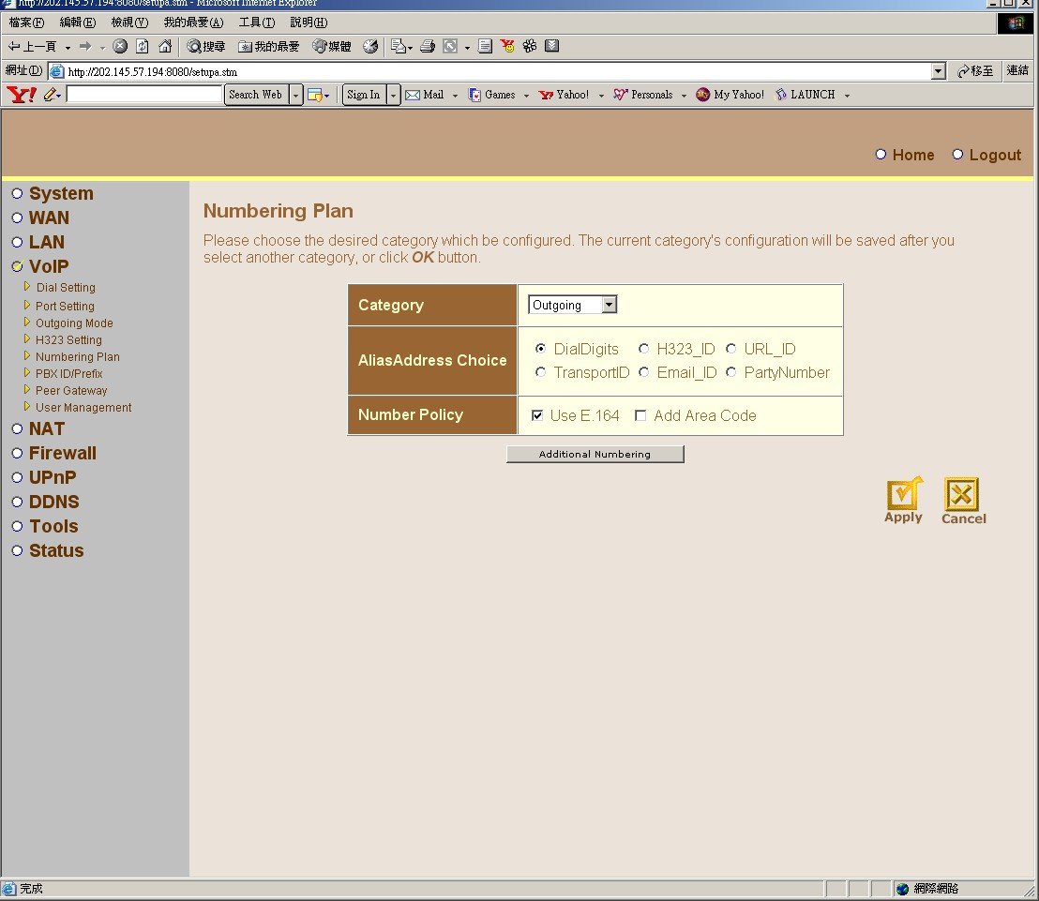

Peer Gateway Database:
The current incoming peer gateway entries is listed in table below. Click Add button to add new entry, or click Delete or Modify button to change the selected entry.
Follow below image.
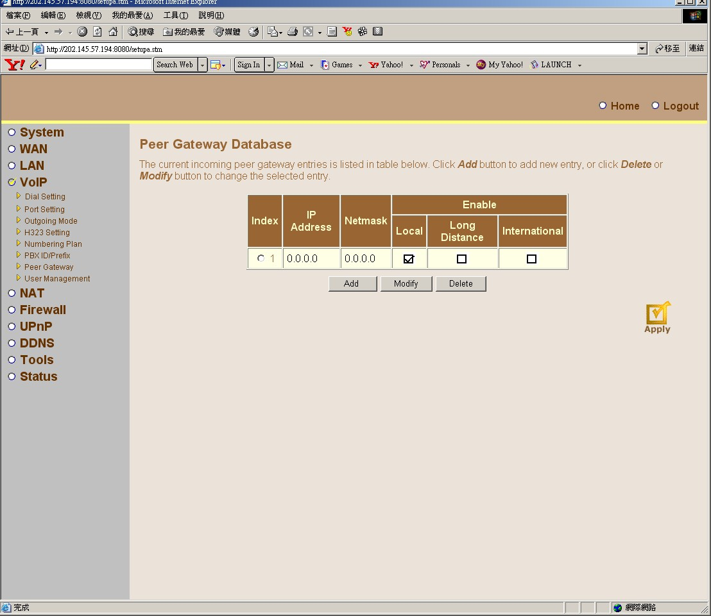

Address Mapping:
Network Address Translation (NAT) allows IP addresses used in a private local network to be mapped to one or more addresses used in the public, global Internet. This feature limits the number of public IP addresses required from the ISP and also maintains the privacy and security of the local network. We allow one or more than one public IP address to be mapped to a pool of local addresses.
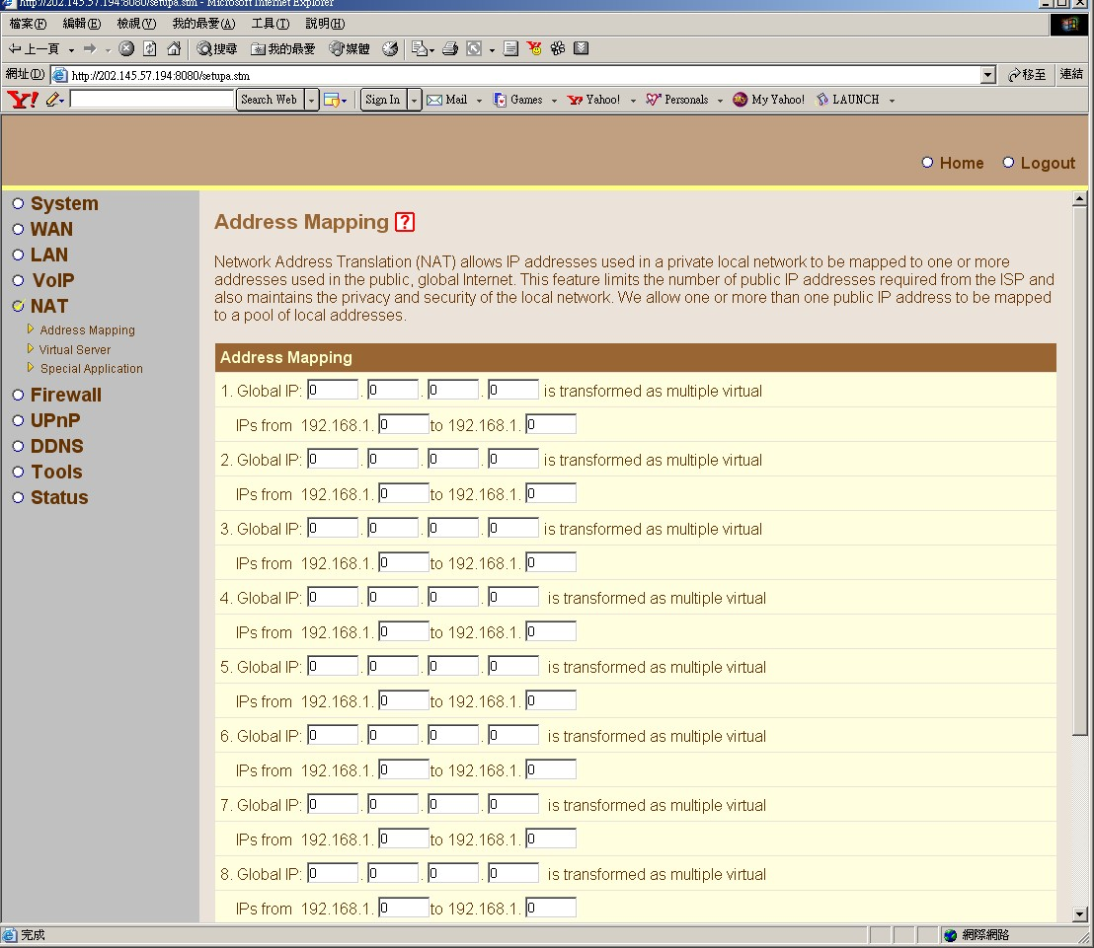

Virtual server:
You can configure the VoRT as a virtual server so that remote users accessing services such as the Web or FTP at your local site via public IP addresses can be automatically redirected to local servers configured with private IP addresses. In other words, depending on the requested service (TCP/UDP port number), the VoRT redirects the external service request to the appropriate server (located at another internal IP address). 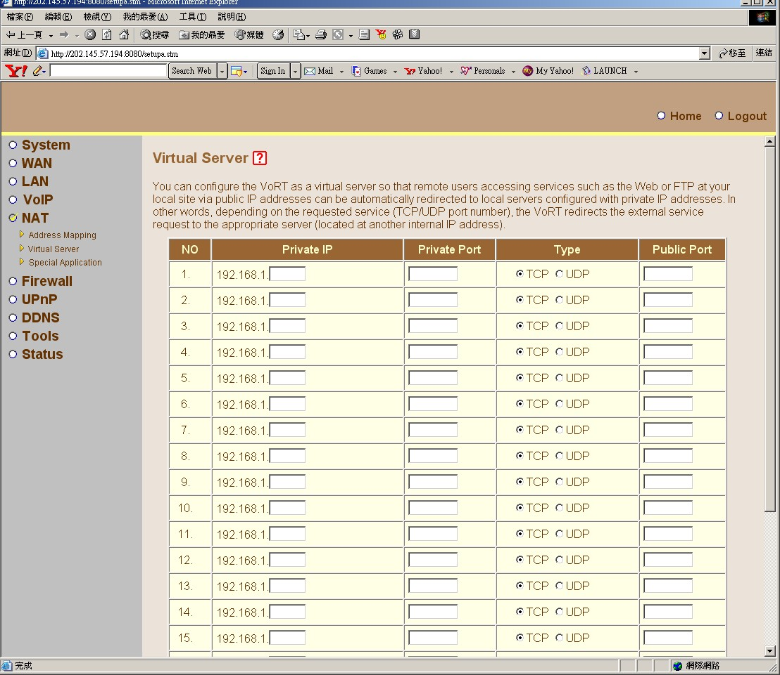

Special Applications:
Some applications require multiple connections, such as Internet gaming, video conferencing, Internet telephony and others. These applications cannot work when Network Address Translation (NAT) is enabled. If you need to run applications that require multiple connections, specify the port normally associated with an application in the "Trigger Port" field, select the protocol type as TCP or UDP, then enter the public ports associated with the trigger port to open them for inbound traffic.
Note: The range of the Trigger Ports is from 0 to 65535.
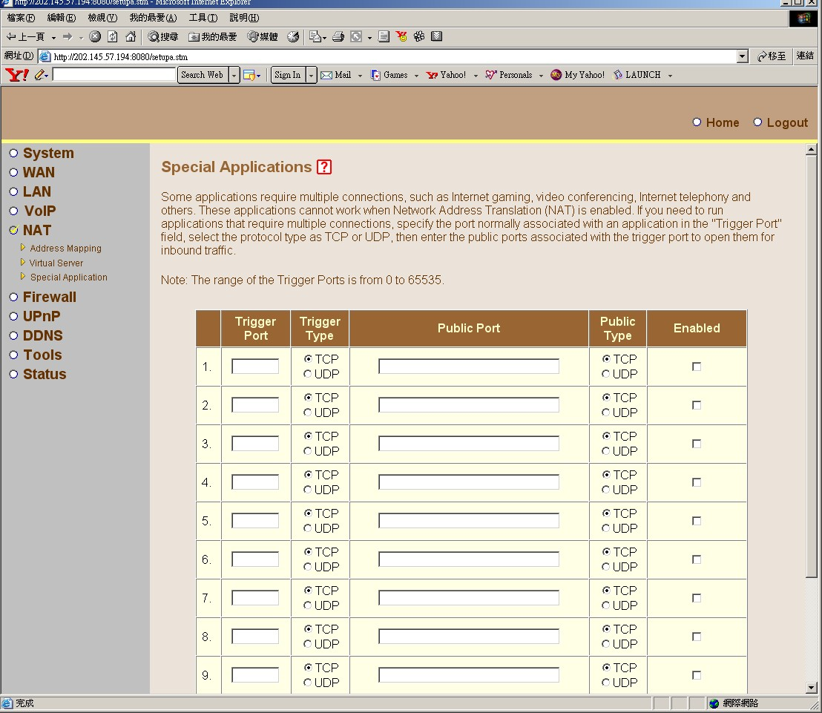

Firewall: The product provides extensive firewall protection by restricting connection parameters to limit the risk of hacker attack, and defending against a wide array of common attacks. However, for applications that require unrestricted access to the Internet, you can configure a specific client/server as a demilitarized zone (DMZ).
Access Control:
Access Control allows users to block PCs on your network from gaining access to the Internet. The user can block PCs based on IP and MAC address.
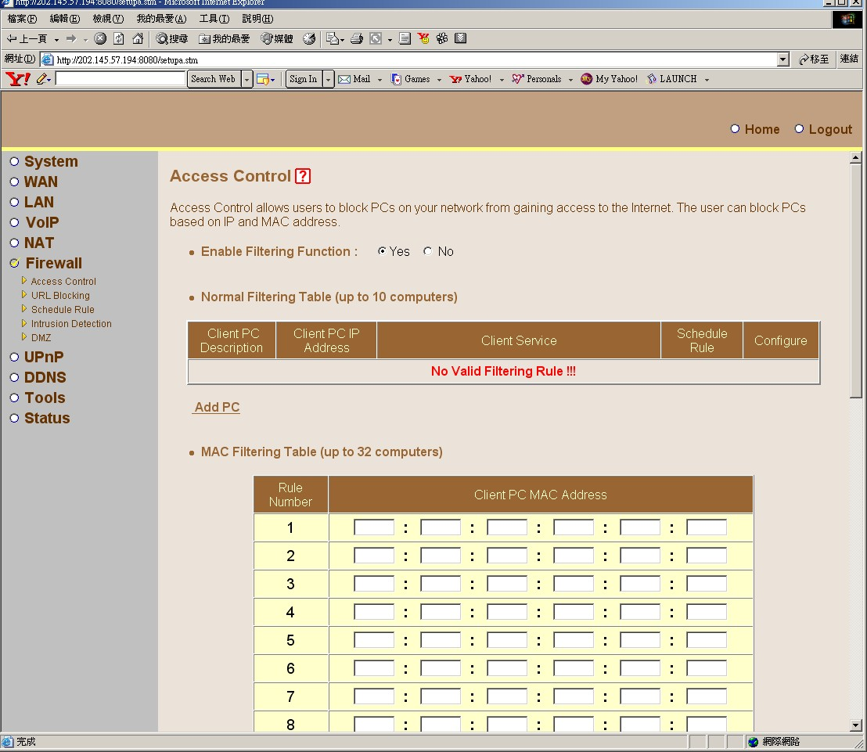

URL Blocking:
Disallowed Web Sites and Keywords.
You can block access to certain Web sites from a particular PC by entering either a full URL address or just a keyword of the Web site.
To specify the particular PC, go back to the "Access Control" page and check the box for "Http with URL Blocking" in the "Normal Filtering Table".
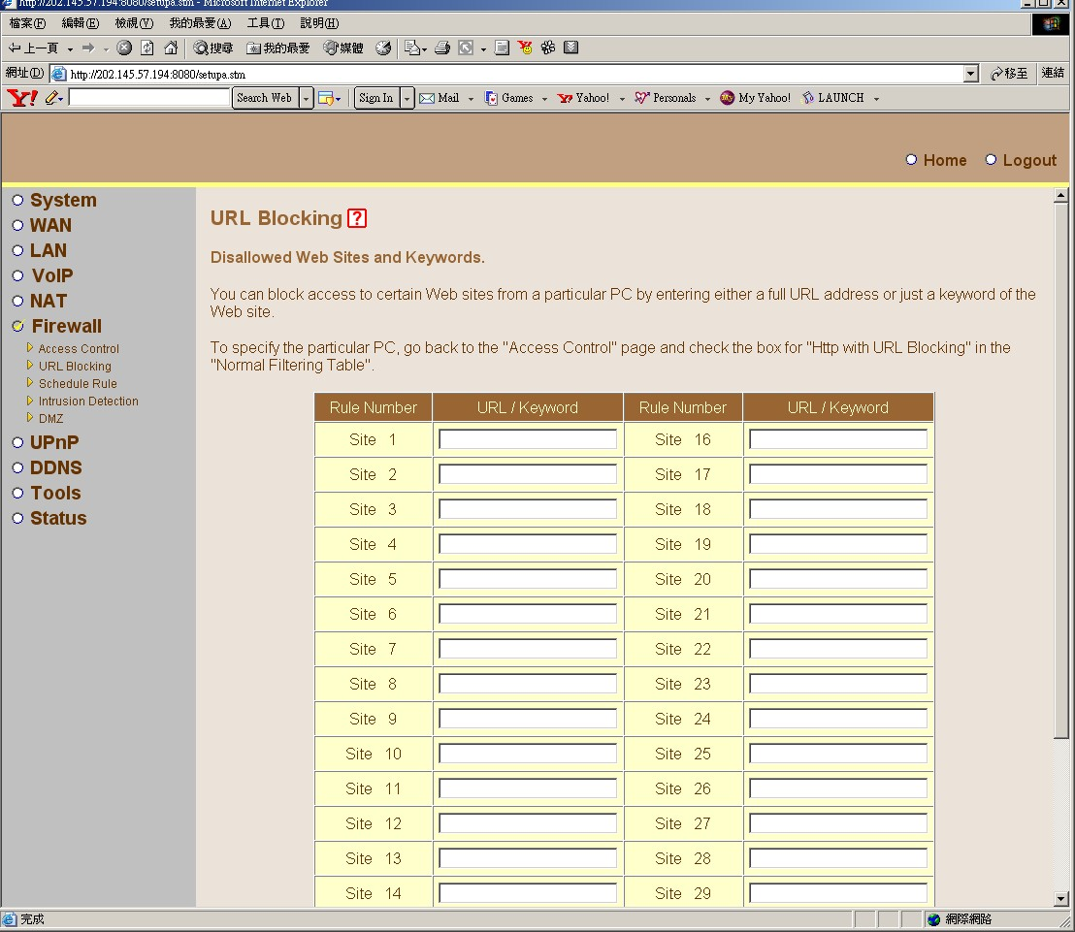

Schedule Rule:
This page defines schedule rule names and activates the schedule for use in the "Access Control" page.
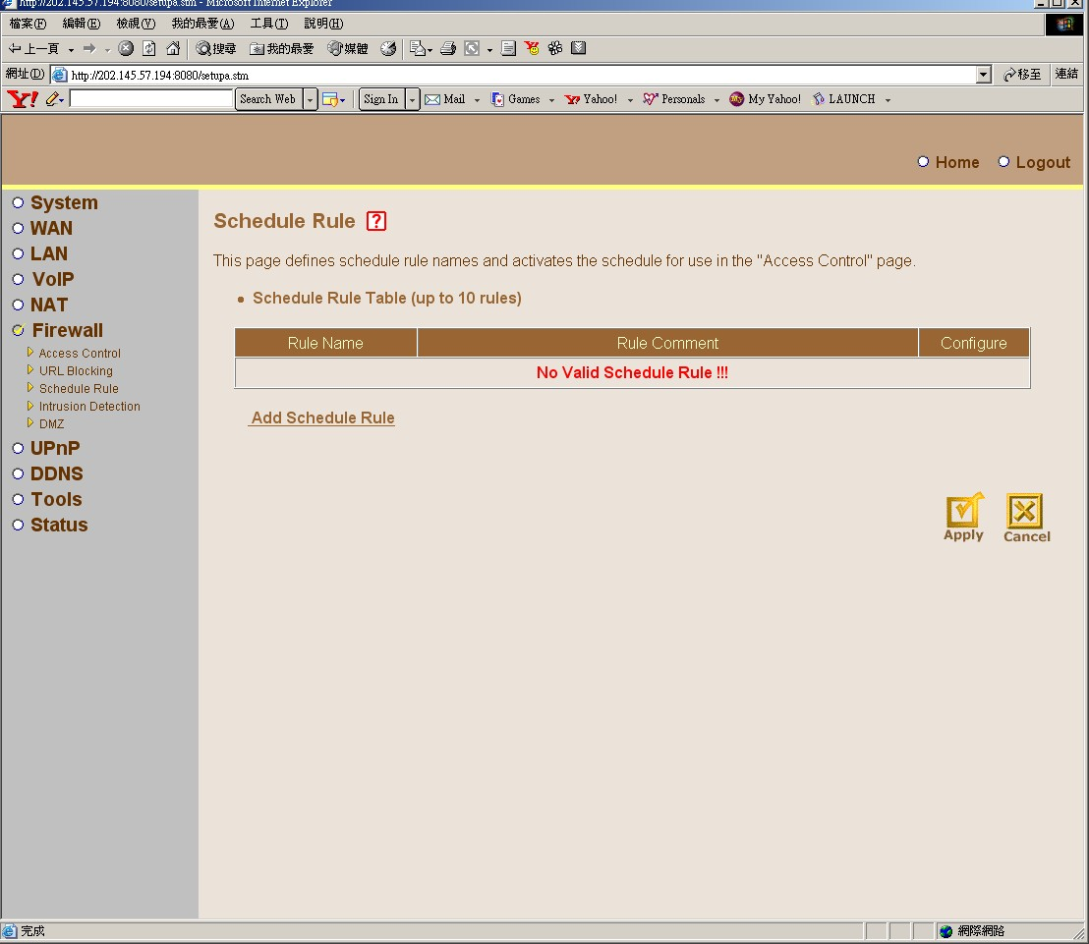

Intrusion Detection:
When the SPI (Stateful Packet Inspection) firewall feature is enabled, all packets can be blocked. Stateful Packet Inspection (SPI) allows full support of different application types that are using dynamic port numbers. For the applications checked in the list below, the product will support full operation as initiated from the local LAN.
The product firewall can block common hacker attacks, including IP Spoofing, Land Attack, Ping of Death, IP with zero length, Smurf Attack, UDP port loopback, Snork Attack, TCP null scan, and TCP SYN flooding.
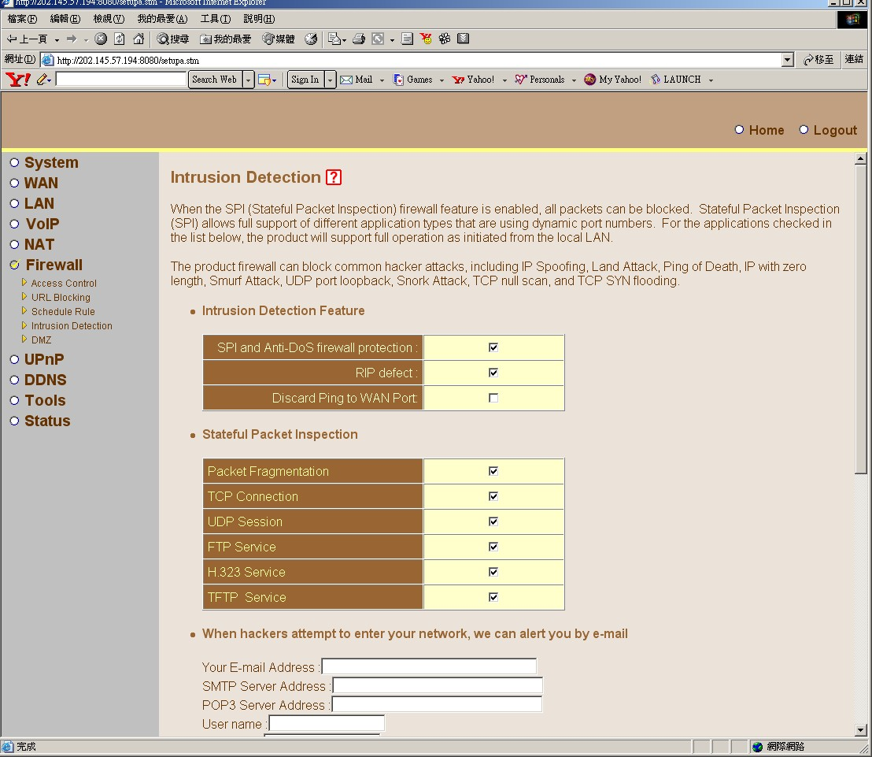

DMZ(Demilitarized Zone):
If you have a local client PC that cannot run an Internet application properly from behind the NAT firewall, then you can open the client up to unrestricted two-way Internet access by defining a Virtual DMZ Host. Multiple PCs can be exposed to the Internet for two-way communications e.g. Internet gaming, video conferencing, or VPN connections. To use the DMZ, you must set a static IP address for that PC.
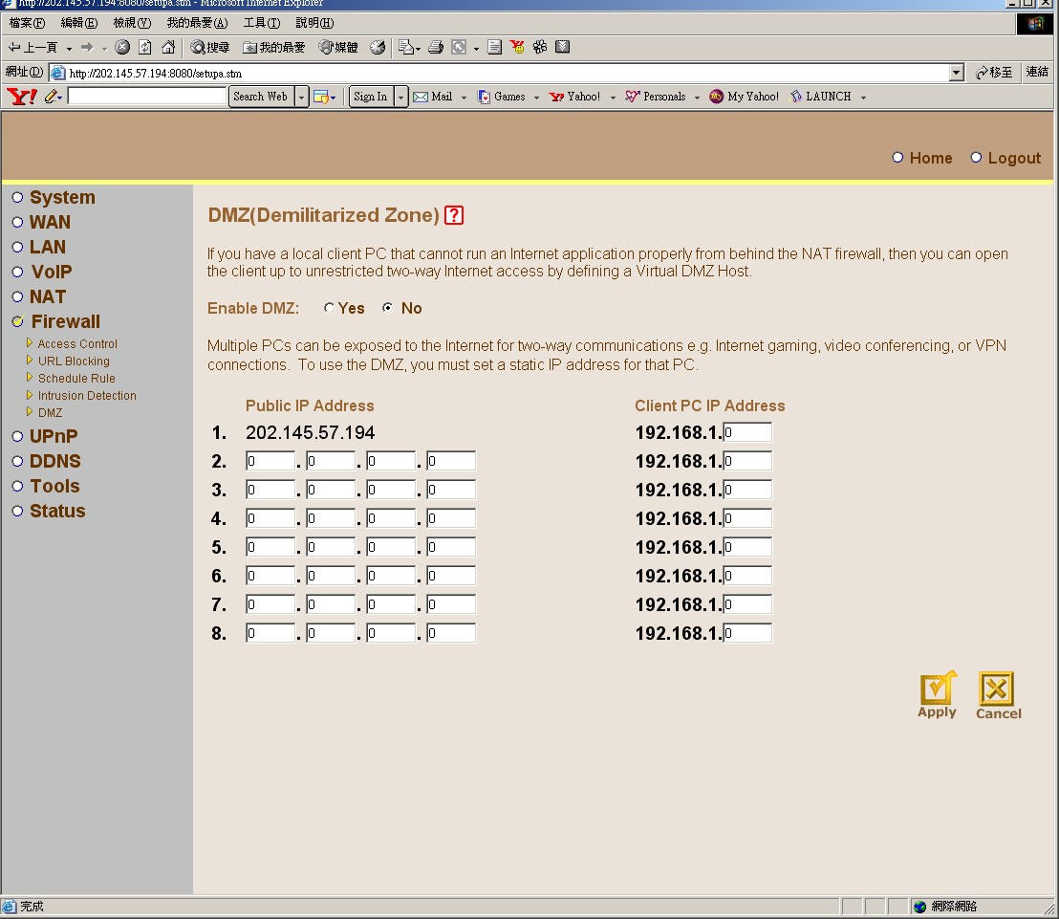

DDNS(Dynamic DNS) Settings:

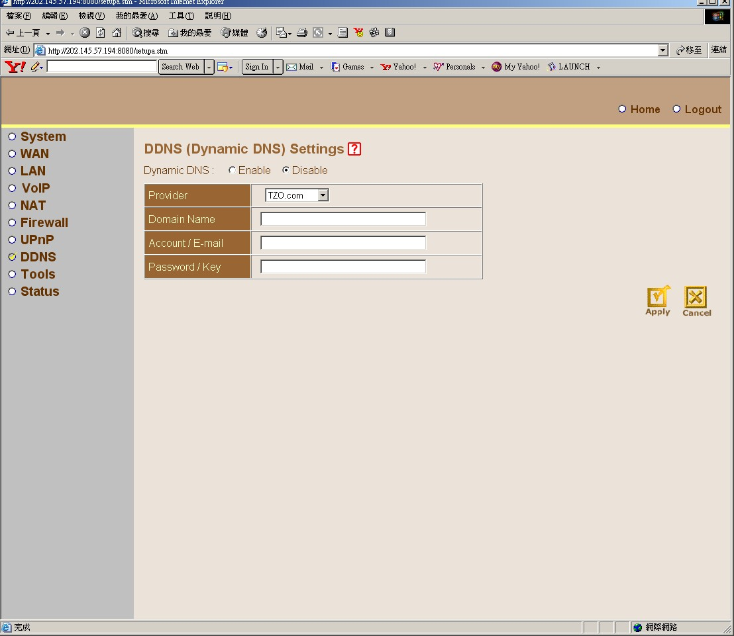

Congratulation Tools:
Use the "Backup" tool to save the current configuration to a file named "backup_config.bin" on your PC. You can then use the "Restore" tool to restore the saved configuration to the machine. Alternatively, you can use the "Restore to Factory Defaults" tool to force the machine to perform a power reset and restore the original factory settings.

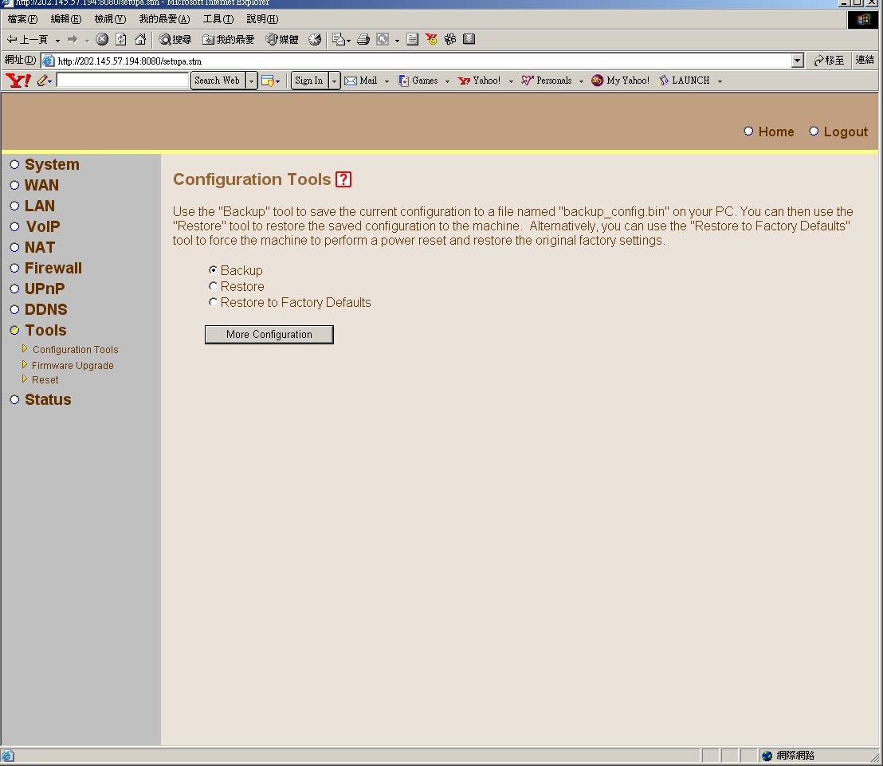

Firmware Upgrade:
This tool allows you to upgrade the product system firmware using a file provided by device vendor.
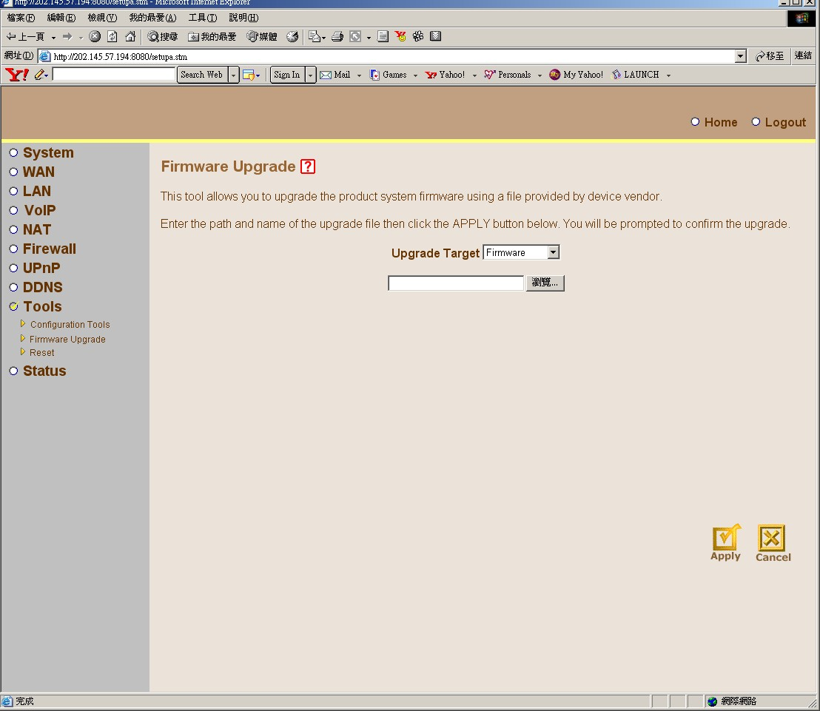

Reset:
In the event that the system stops responding correctly or in some way stops functioning, you can perform a reset. To perform the reset, click on the APPLY button below. You will be asked to confirm your decision. The reset will be complete when the power light stops blinking.
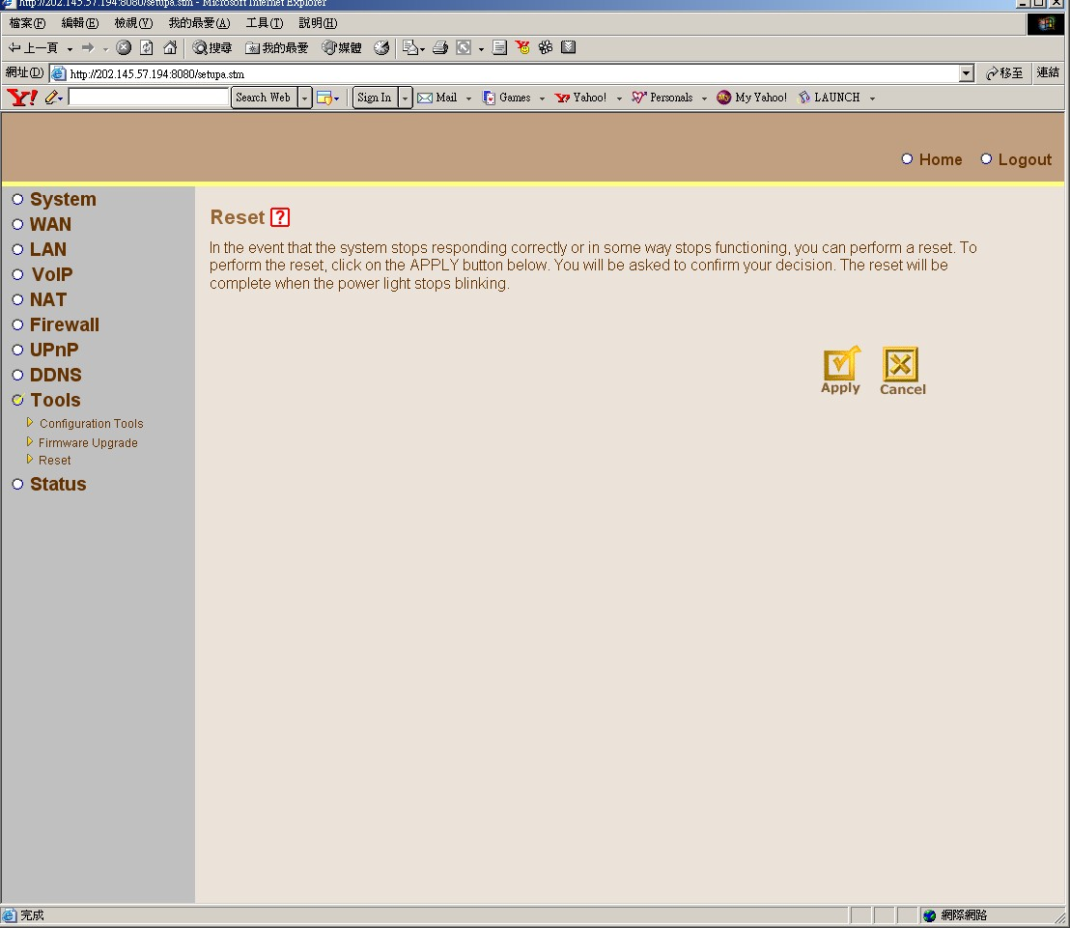

Status and Information:
You can use the Status page to see the connection status for the product's network interfaces, firmware and hardware version numbers.
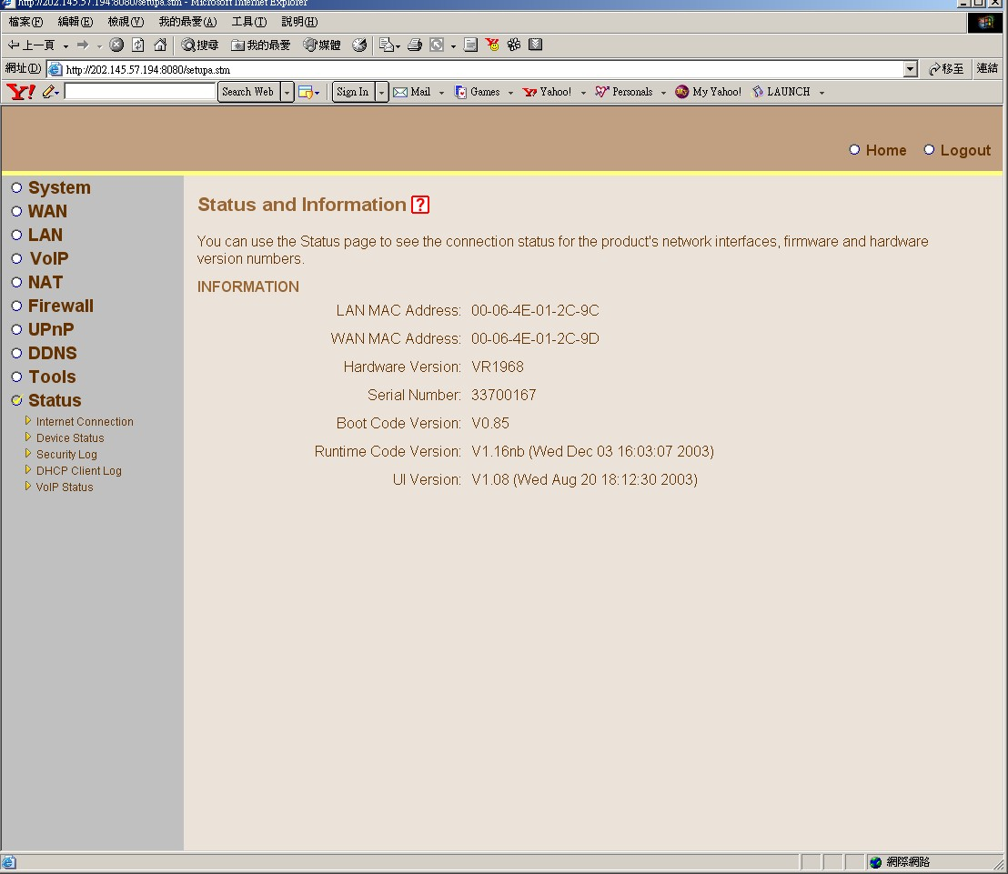

Internet Connection:
View the current internet connection status and related information
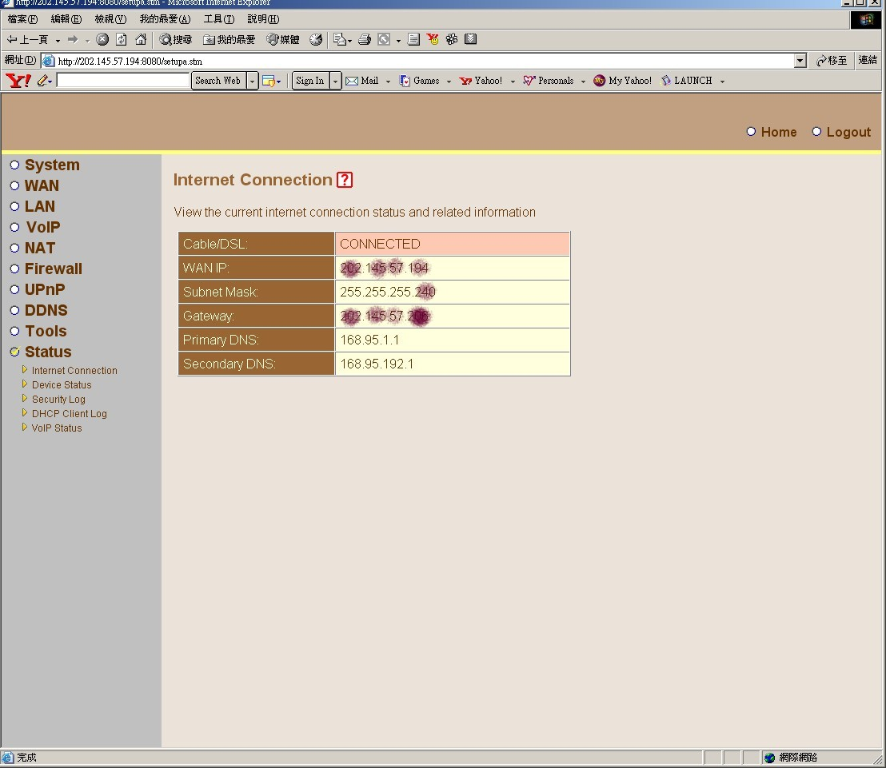

Device status:
View the current setting status of this device.
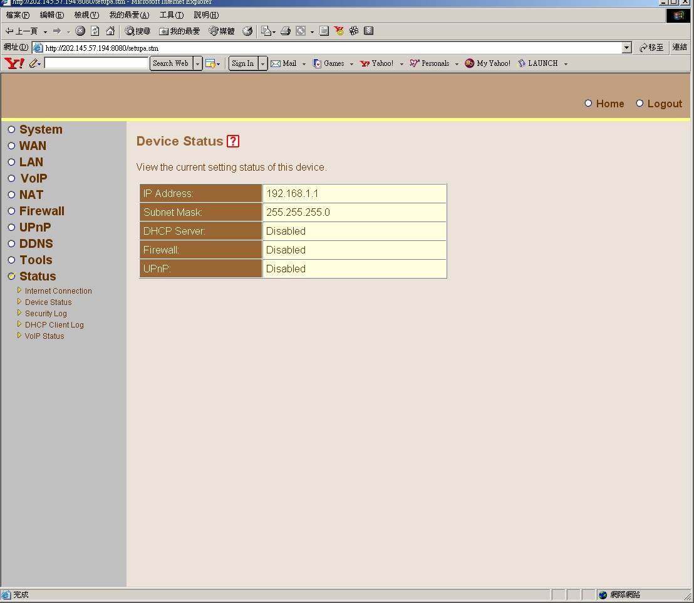

Security Log:
View any attempts that have been made to gain access to your network.

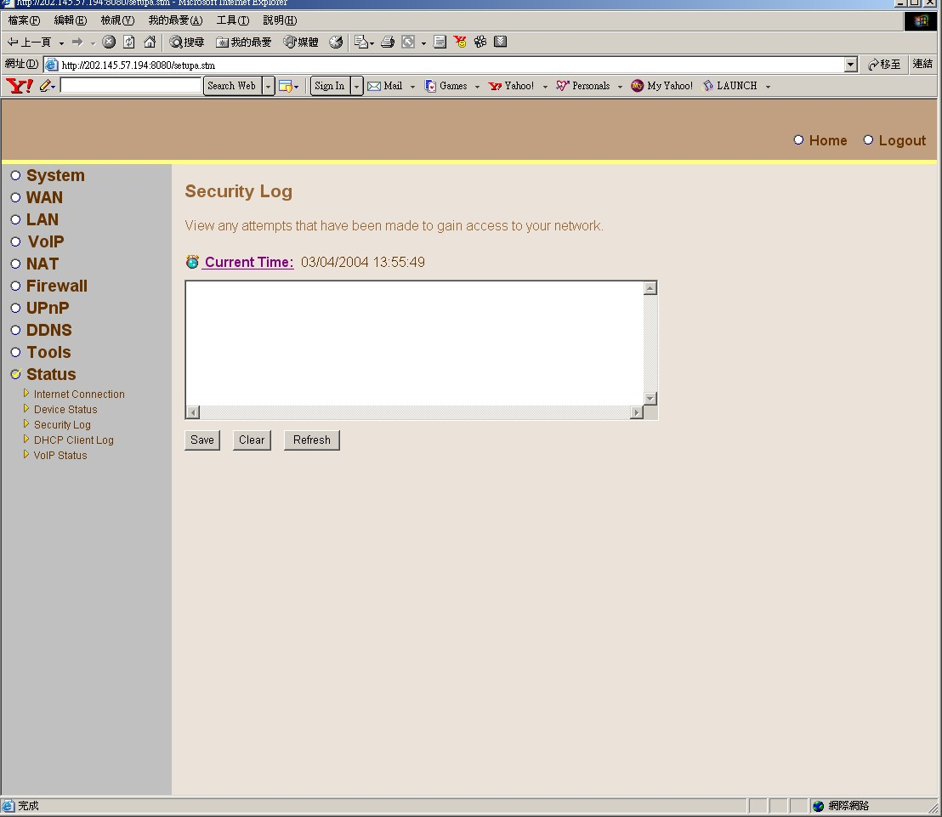

DHCP Client Log:
View information on LAN DHCP clients currently linked to the product.
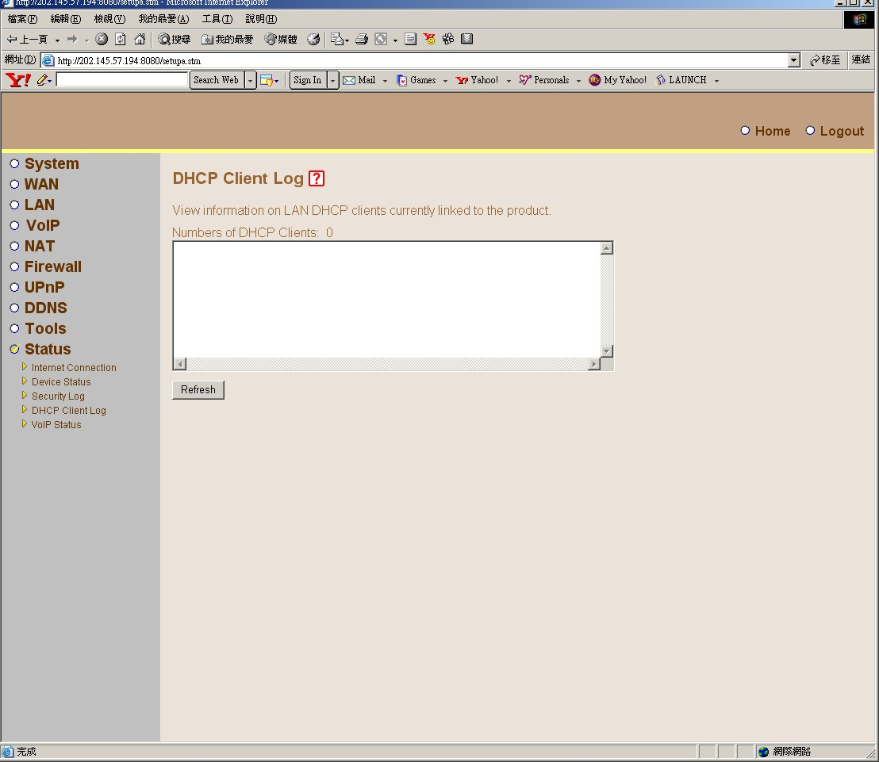

VOIP status Monitoring:
Phone Port Status:
Gatekeeper Status:
When show below mean work well.
Gatekeeper Registered at 210.244.221.250(OpenH323GK)


